Thawing Relations: Teaching about Cuba and the U.S.
Subject: History
Overview | For more than half a century, the United States has feuded — sometimes to the edge of war — with the island nation of Cuba. Now that mutual hostility could be coming to an end with last month’s announcement that the two countries will resume diplomatic relations. How will life change for people in both countries?
In this lesson we explore different facts of this historic relationship and give students a chance to predict what might come next. Students can begin by taking a journey across Cuba, compare it with life in their own hometown, and take part in a role-playing exercise on different perspectives in the United States-Cuba relationship. In follow-up activities they can delve more deeply into the history, culture, economics and politics of the communist nation 90 miles south of Florida.
Lesson Plan: If You Have Only One Class Period …
1. Start with what students know.
Spend a few minutes comparing and contrasting what students have heard about Cuba and the United States in terms of history, government, economy, daily life and culture. Students can use a comparison matrix (PDF) or Venn diagram (PDF) to organize their thoughts.
2. Find out what’s happened.
Watch this Associated Press video, “Key Events in U.S. and Cuba Relations,” for a quick overview of recent history. Ask students what surprised them in the video, and give them a moment to add to their diagrams. (If you have time, you can also review last month’s announcement about the resumption of diplomatic relations and other recent changes between the United States and Cuba.)
3. Take a trip across Cuba and learn more.
As a class, view this slide show (above) with students reading the captions aloud. Then read “On the Open Road, Signs of a Changing Cuba,” in which New York Times reporter William Neuman traveled across the island earlier this month. Before starting, teachers may wish to review the following vocabulary terms: socialism, entrepreneurship, ideology, revolutionary, imperialism and bureaucracy. Afterward, students can discuss what they’ve learned and add further details to their diagrams.
4. Consider other perspectives.
Organize students into the following broadly-characterized groups. Each group should take around 10 minutes to brainstorm an initial response to this question: What are the challenges and opportunities facing Cuba and the United States as they embark upon a closer relationship?
- Older Cuban citizens. Some of you work for the government and are members of the Communist Party. Others in your group work as doctors, engineers or managers, and may have gained your position by following the rules. In school you were taught to be suspicious of the United States, regarding it as a hostile nation intent on dominating Cuba, but lately some of you are not so sure.
- Younger Cuban citizens. Members of this group hold a variety of jobs, such as tourist-hotel doorman, farmer, fisherman or schoolteacher. With the average salary in Cuba near $20 a month, it has often been a struggle to make ends meet, and some of you are not convinced (PDF) the government has done all it can to improve life in Cuba.
- Older Cuban-Americans. You or your relatives fled Cuba after the revolution in 1959, and you might have had property taken by the communist government and given to the state, or felt harassed because of personal beliefs. Some in your group continue to regard that government with suspicion or hostility (PDF), while others might be open to new views after 55 years of conflict.
- Younger Cuban-Americans. You weren’t born when Cuba and the United States slipped into conflict, and many of you are more open than your older relatives (PDF) to improving ties with Cuba.. Some of you work in business and might be interested in trading with Cuba if the embargo ends, or you might be interested in traveling there some day.
Each group should then present its findings, beginning with the phrase, “We believe.” Each group should conclude by announcing whether its members support or oppose the decision to resume diplomatic relations and move toward a closer economic relationship.
As an option for classes that want to go into even more depth, teachers can also assign students to read an additional article — “Where Is Cuba Going?” by John Jeremiah Sullivan — and ask them to develop more detailed characters within their groups. Students can do additional research on their characters’ stories and perspectives using the Going Further resources below, and then groups can present their findings in character.

A Decades-Long Thaw in U.S.-Cuba Relations
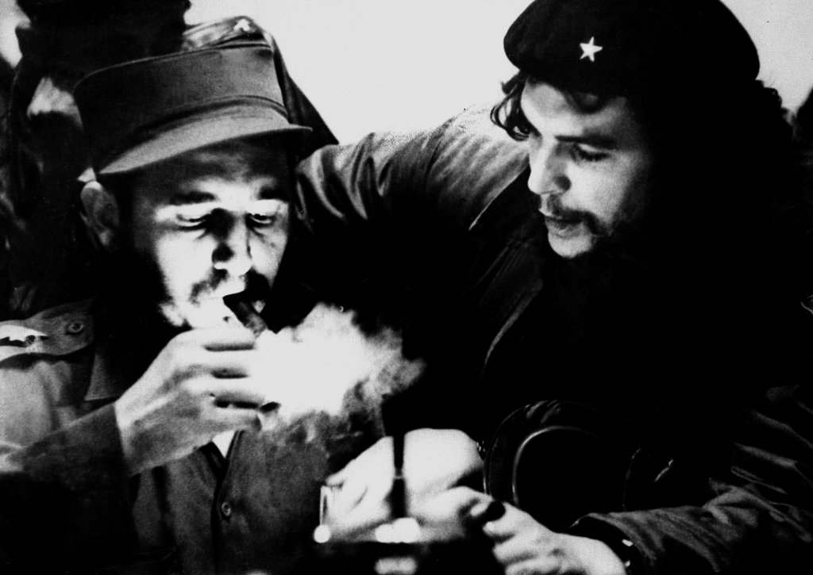
Fidel Castro with Che Guevara in 1959, the year Mr. Castro took power after leading a communist revolution in Cuba and toppling the American-backed dictator Fulgencio
Batista.

Going Further
How did the United States and Cuba finally settle their differences, and what did spies have to do with it?
The agreement to resume diplomatic relations with Cuba came about only after a flurry of negotiations that involved spies, secret meetings and even an assist from the pope. Hear what President Obama and Raúl Castro, Cuba’s president, had to say, and find out the details of exactly what will change. Read the story about the United States government contractor, three Cuban spies, one American secret agent and 53 Cuban political prisoners who were released as part of the agreement. Then decide for yourself: Was this a good agreement, and why?
Do all Cuban-Americans feel the same way about this news, and why does the issue get United States politicians so riled?
Cuban-Americans reacted with astonishment to the news that the United States would resume diplomatic relations with Cuba. But views have been changing in recent years and Republicans can no longer count on support from the Cuban-American population. Read this report from the Pew Research Center on changing attitudes in the Cuban-American community, and learn how waves of Cuban migrants have influenced the city of Miami over the years. Then listen to the views of one Cuban-American politician, United States Senator Marco Rubio, and decide whether his views represent the majority.

A National Pastime Perseveres
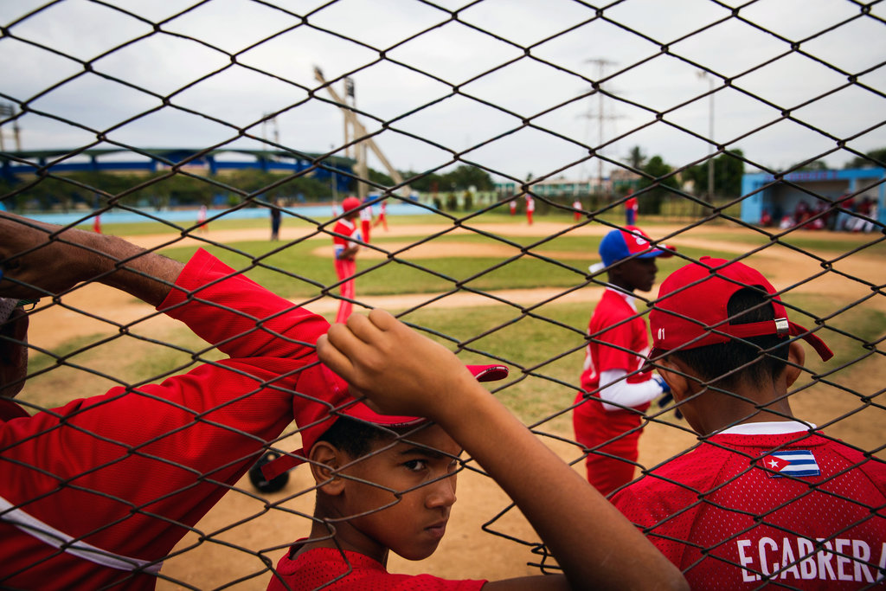
At the Ciudad Deportiva complex in Havana, two neighborhood teams, Marianao and Guanabacoa, featuring 11- and 12-year-olds, played a game.
Credit: Josh Haner/The New York Times

How have Cuban athletes been affected by the American trade embargo and life under communism, and will improved relations help their sports?
Cubans are avid baseball fans, and Major League Baseball teams are equally fascinated by the opportunity to get more involved with the country. But other sports are popular too — boxing, track and field, soccer and even surfing. Read about what athletes have said about life under communism and the embargo, and what they’re hoping for as relations thaw with the United States. Then decide: Can sports help to improve relations between the two countries? Give a presentation explaining your answer, using evidence and quotes from the articles you’ve read to defend what you think.
Is capitalism a completely new idea for Cubans born after the 1959 revolution, or do they have some experience with it?
While Cuba’s communist government has kept a relatively tight gripon the economy, it has allowed citizens more economic freedom in recent years. And the country is already conducting some forms of trade with the United States. Read some of the articles below, keeping track of the ways in which economic life has changed year by year. Then draw an annotated timeline in poster form, using facts, quotes, illustrations or sketches from the articles to show what you’ve learned.
- Havana Journal; On the Street, Cubans Fondly Embrace Capitalism (1994)
- Cuba Details New Policies on Budding Entrepreneurs (2010)
- A Black Market Finds a Home in the Web’s Back Alleys (2010)
- Cubans Set for Big Change: Right to Buy Homes (2011)
- Feeding the People in Cuba (video, 2012)
- Cuba’s Free-Market Farm Experiment Yields a Meager Crop(2012)
- Cuba Unleashes the Pent-Up Energy of Real Estate Dreams (2012)
- Amid Fealty to Socialism, a Nod to Capitalism (2013)
- What U.S. Companies Can Expect in Cuba (2014)
- U.S. Companies Clamor to Do Business in New Cuban Market(2014)
- Cuba’s Economic Fortunes May be Slow to Turn (2014)

Other Resources
Flash Points: Searching for Modern Lessons in the Cuban Missile Crisis
Cuba: The Art Revolution (PBS Frontline)
Cuba: The Next Revolution (PBS, Black in Latin America series)
Cuba (The Brookings Institution)
As Cuban American Demographics Change, So Do Views of Cuba(Pew Research Center)
Cuban Research Institute (Florida International University)
F.I.U. Cuba Poll (2014)
The Gallup Poll of Cuba (2007)
Timeline: U.S.-Cuba Relations (The Council on Foreign Relations)

Standards
This resource may be used to address the academic standards listed below.
View all

